MODULE 2
QUESTION AND ANSWER 1:
https://www.hackerrank.com/challenges/conditional-statements-in-c/problem
#include <stdio.h>
int main() {
int n;
scanf("%d", &n);

if (n == 1)
printf("one");
else if (n == 2)
printf("two");
else if (n == 3)
printf("three");
else if (n == 4)
printf("four");
else if (n == 5)
printf("five");
else if (n == 6)
printf("six");
else if (n == 7)
printf("seven");
else if (n == 8)
printf("eight");
else if (n == 9)
printf("nine");
else
printf("Greater than 9");

return 0;
}
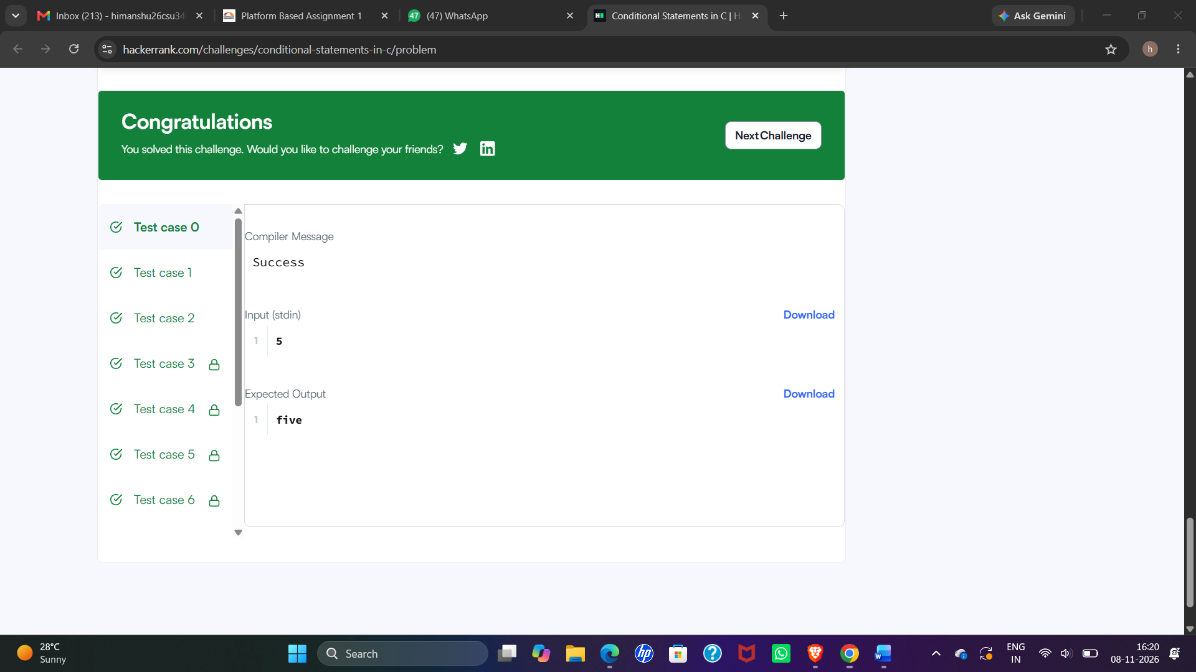

MODULE 2
QUESTION AND ANSWER 2:
https://leetcode.com/problems/smallest-even-multiple/
int smallestEvenMultiple(int n) {
if (n % 2 == 0) {
return n;
} else {
return n * 2;
}
}
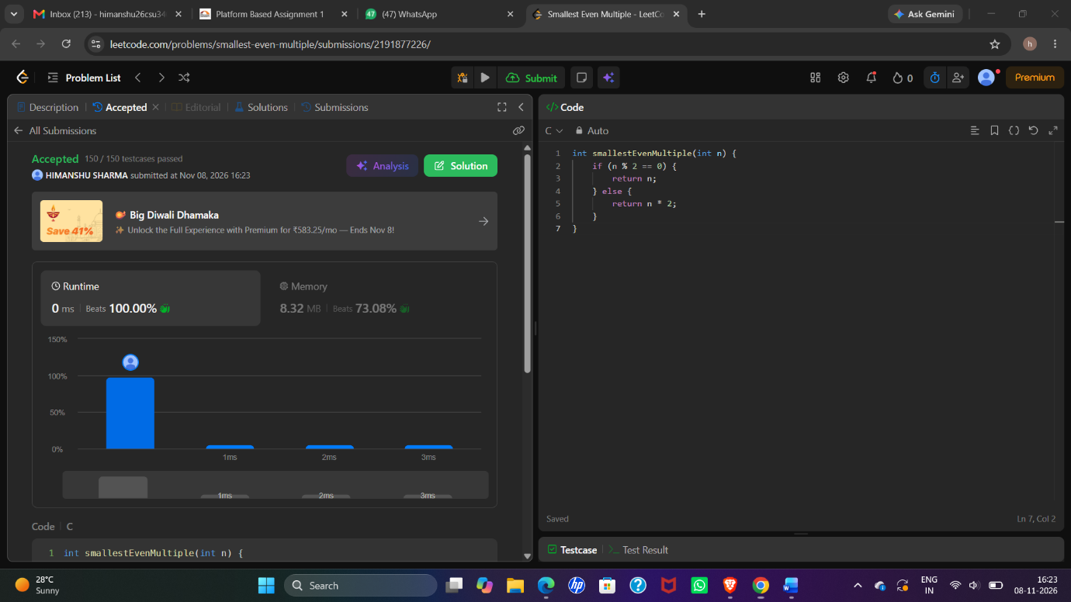

MODULE 2
QUESTION AND ANSWER 3:
https://www.hackerrank.com/challenges/grading/problem
#include <stdio.h>

int main() {
int n;
scanf("%d", &n);

int grades[n];

for (int i = 0; i < n; i++) {
scanf("%d", &grades[i]);
}

for (int i = 0; i < n; i++) {
if (grades[i] < 38) {
printf("%d\n", grades[i]);
}
else if (grades[i] % 5 >= 3) {
printf("%d\n", grades[i] + (5 - grades[i] % 5));
}
else {
printf("%d\n", grades[i]);
}
}

return 0;
} 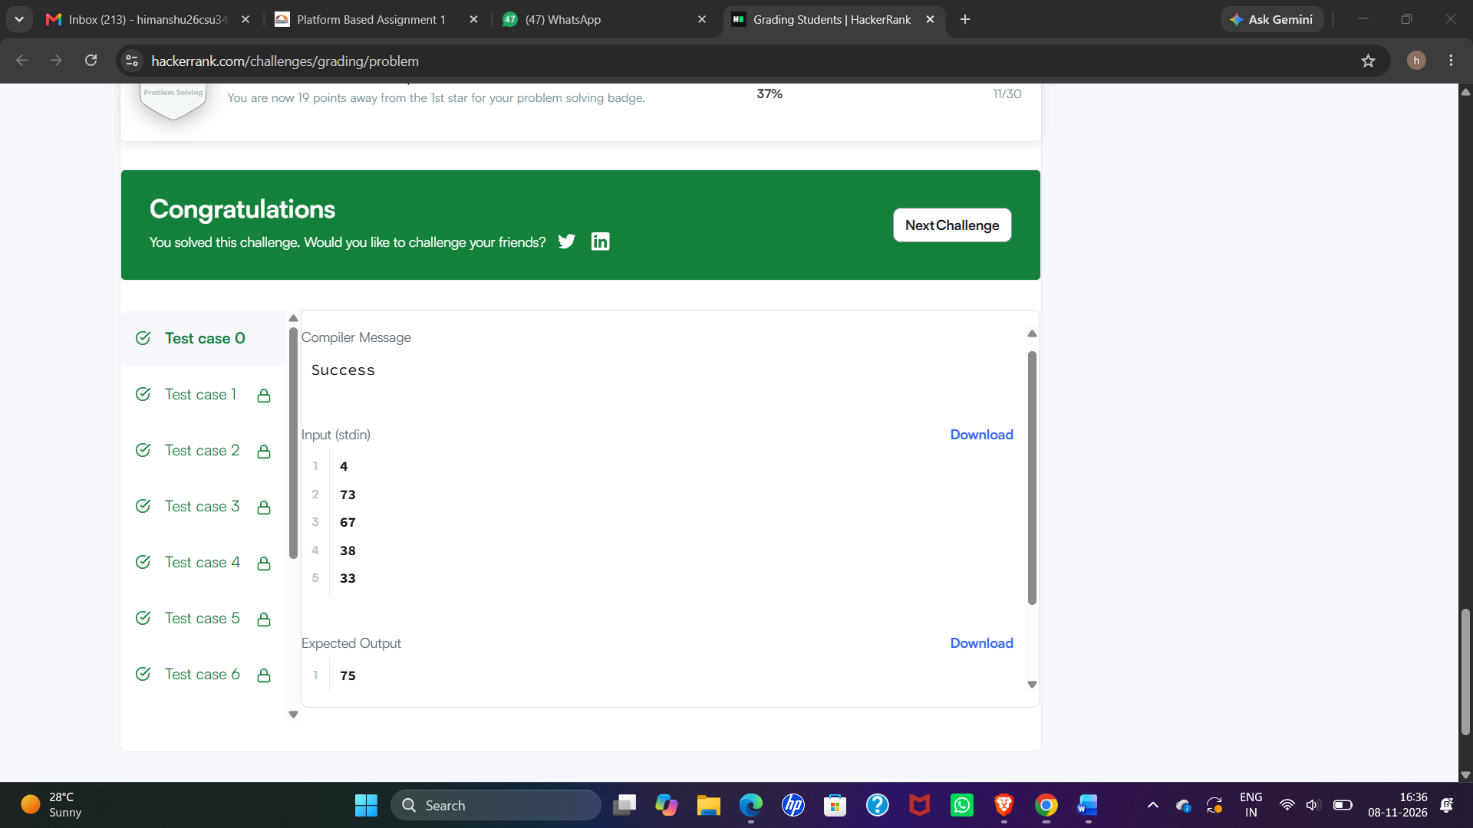

MODULE 2
QUESTION AND ANSWER 4:
https://www.hackerearth.com/practice/basic-programming/input-output/basics-of-input-output/practice-problems/algorithm/roy-and-profile-picture/
#include <stdio.h>

int main() {
int L, N, W, H;

scanf("%d", &L);
scanf("%d", &N);

for (int i = 0; i < N; i++) {
scanf("%d %d", &W, &H);

if (W < L || H < L) {
printf("UPLOAD ANOTHER\n");
}
else if (W == H) {
printf("ACCEPTED\n");
}
else {
printf("CROP IT\n");
}
}

return 0;
}
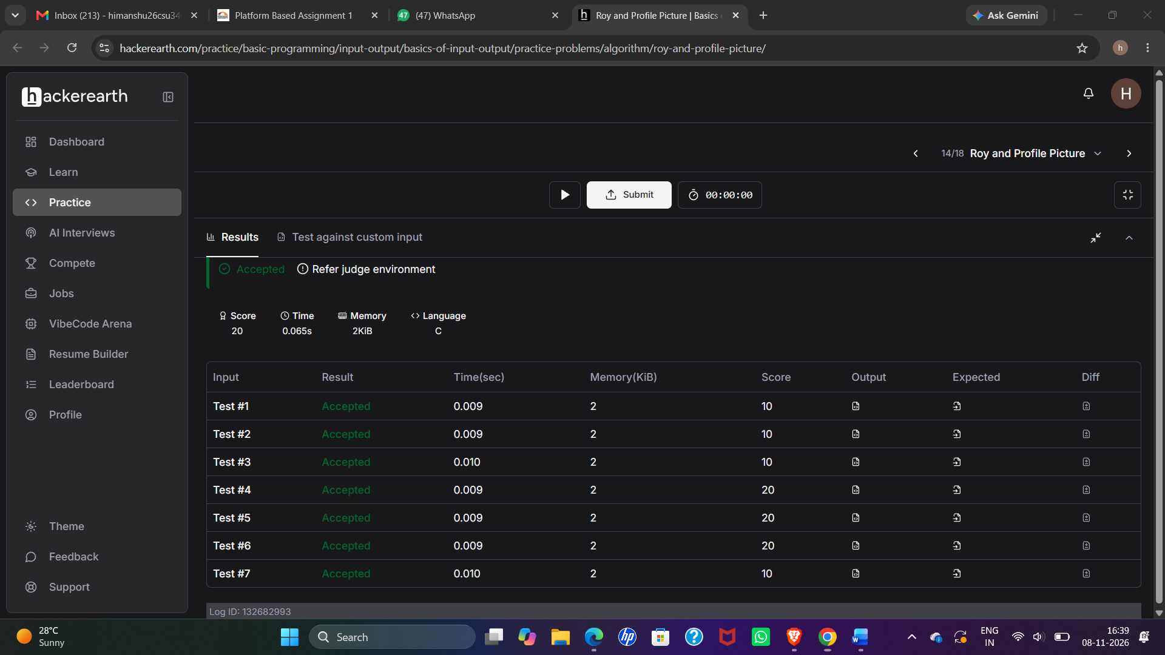

MODULE 2
QUESTION AND ANSWER 5:
https://www.hackerrank.com/challenges/fizzbuzz/problem
#include <stdio.h>
int main()
{
int i;
for(i=1;i<=100;i++)
{
if(i%3==0 && i%5==0)
printf("FizzBuzz\n");
else if(i%3==0)
printf("Fizz\n");
else if(i%5==0)
printf("Buzz\n");
else
printf("%d\n",i);
}
return 0;
}


